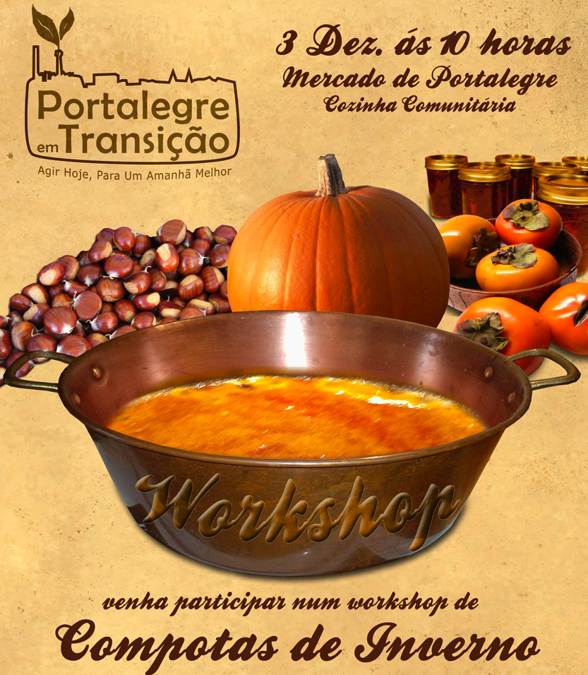

Re-skilling
Workshop - winter jams

3/12/2011
Market of Portalegre, Portugal

A working group within ‘Portalegre em Transiçao’ decided to go through with an activity proposed long ago by somebody in our community. Originally, the suggestion for the activity referred to the classical Summer/Autumn jams. However, in result of several agenda obstacles, we did not manage to organize it during the season one would feel more convenient. Finally, we thought:
- Why not? Why not having this same activity repeated four times a year?
Traditionally, one can conserve fruits of all seasons, right?

Portugal is going through a truly difficult crisis. This crisis has a huge impact in the Portuguese community and for inland semi-rural regions, as Portalegre, life is probably even more difficult.

Therefore, we feel that Transition should respond to these new society’s limitations and needs, proposing ways of reacting to crisis positively, ‘doing the right thing’, in community and having fun. All this, having in mind concepts as social justice, respect for the environment, the richness of including everybody, all ages, from all backgrounds!

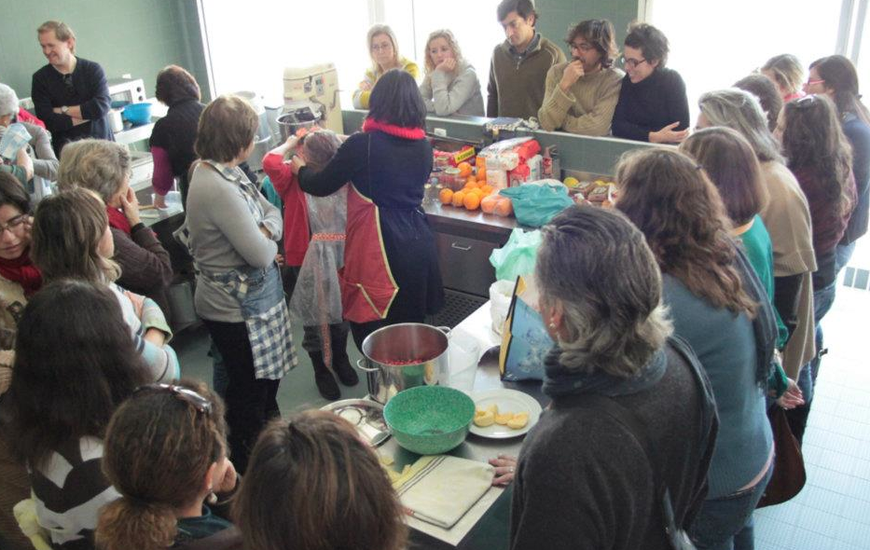

The concept: free of charge, co-organization and co-responsabilisation and an inclusive communitarian experience

- The space

The local public authority let us use the communal kitchen placed within a covered public market. Actually, the place offers perfect conditions for this kind of workshop – the kitchen is working in perfect order, it can host around 30 people, there is covered space outside for parallel activities, the space is common to where local producers are selling their products. We could use the gas and electricity free of charge.

- Organization

In all new activities this TI organizes, new people are invited to integrate the coordination team. Normally, we invite one person of the community who suggested the theme or initiative. In this case, the main team was composed by 2 active members of the TI and 2 external people (who integrated the TI after the activity)

- Participation

We chose to propose a different concept of workshop: instead of inviting one (almost) professional trainer, we preferred to have a truly sharing experience – one would register to learn only or to learn and share a recipe. Nobody was professionally involved in this kind of activities before.
The recipes were gathered in a book. The printed versions were to be taken away a donation and, otherwise, the book was made available in the social networks and could be downloaded here: (http://issuu.com/pemt/docs/pemt_compotas_de_inverno)

- Co-responsabilization

Once we gathered the list of people registered and the recipes, we made the list of the required ingredients and asked everybody to choose what they would like to bring. To ease that task, we used a Doodle (ingredients instead of the dates), following the example of an event organized earlier this year in one of our sister TIs in Sintra: http://www.doodle.com/nn2eygz6ix55ct46. Participants could then allocate the ingredient and its quantities to be brought by them.

- Communitarian experience

The event was thought to be a cool sharing experience while having fun. We got participants of all ages; young children were taken care as well, allowing parents to fully participate. Once the jams were ready, they were put outside the kitchen, on a table, with information about Transition and the TI and were offered to the participants and people stopping and passing by.

We had to limit the registrations: we had more than 30 participants and we had much more requests. We invited everybody in and out the event to share a meal after the workshop: in the end it was a fantastic gathering with families, friends, other local organizations, etc.

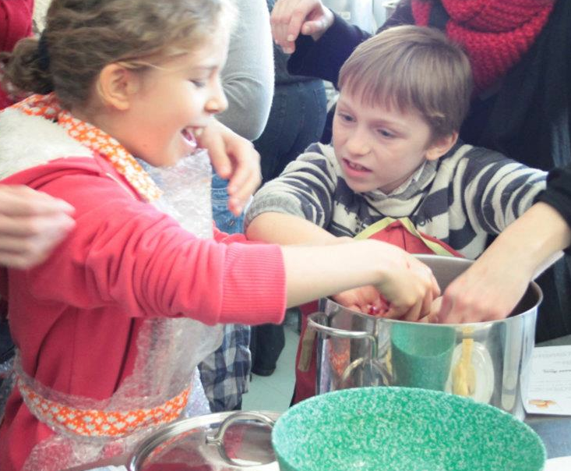

The future:
Loads of ideas got out of this activity and some of the participants will clearly become active members of the TI.
Suggestions for future activities:
- Traditional liqueurs (14 of January)
- Regional pastry
- Bread
- Re-vamping “Fridge food”
- Sowing and up-recycling old clothes
- Knitting
- Make your presents

Photos: http://www.facebook.com/media/set/?set=a.260990927292189.69766.140426666015283&type=3

