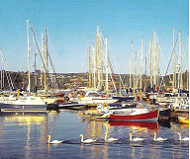
Kinsale

Transition Town

Projects for 2006

Presented by:
Louise Rooney, Transition Design

Introduction

Further to the motion tabled by Cllr Treacy in the December meeting of the Town Council, which was unanimously supported, Transition Design have been looking at how to proceed with the goal to move Kinsale from fossil fuel dependency to energy independence. We envisage one of the primary strategic steps that need to be taken is for Kinsale Town Council to develop an ‘ecological charter’. This will act as a frame of reference for all decisions made in the town, giving them a guiding principle. There is little point in Transition Design promoting energy conservation and reduction in fossil fuels, if decisions made by the council are in opposition to those goals, e.g., the installation of oil-fired central heating in council housing.

In addition to the development of an ecological charter, Transition Design wishes to focus on Food Security in their 2006 projects. To this end we have identified the need for a Community Garden, a Community Compost Scheme and Information Leaflets to promote these initiatives to the people of Kinasale.

We respectfully request financial support from Kinsale Town Council to help us establish the following projects:

- Community Garden: estimated set-up cost €7,984
- Community Compost Scheme: estimated cost €600
- Information Leaflets: estimated cost €2,000

Estimated total budget requirement: €10,584

Ecological Charter

We’re very aware that the goal that Kinsale has adopted to reduce its fossil fuel dependency is quite an ambitious one. The work of Transition Design is not in isolation. In fact, for the combined efforts of the community of Kinsale, Transition Design and the Town Council to be in harmony, ideally what we should be working towards is an ecological charter for the town. This would cover such areas like: any new developments in the town must demonstrate use of local resources, be environmentally conscious, and bring visible benefits to the town of Kinsale; encourage existing businesses to adopt environmental codes of practice; vacant, unused buildings need to be prioritised for development over granting planning permission for new developments and so on. I believe if we work together on this, we could come up with the first ecological charter ever signed by a town in Ireland, again putting Kinsale in the headlines.

There are huge opportunities for Kinsale in developing the concept of Transition Town. Eco-tourism is an emerging market, as are renewable energies and alternative heating sources. If Kinsale is to position itself as a ‘Green’ town this would attract suppliers to set up in the town and also increase employment here, not to mention encouraging protection and development of the environmental integrity of the town. Back in 1995 we won a European prize for Tourism and the Environment, imagine how much better placed we would be if we consciously worked towards developing an ecological charter, and worked as a community to implementing it?

1. Community Garden

The creation of a demonstration site for food growing within the town is of paramount importance with regard to developing food security in Kinsale. We call this a ‘Community Garden’, that is, not a garden for aesthetic purposes (although it will be lovely!), but one that grows vegetables, herbs and fruit trees, and one that is capable of developing into an educational resource where locals can go to learn the art of organic growing.

However, we are not only looking for the financial aid to kick start such a garden in Kinsale, we also depend on the council to grant us permission to use some available plot of land in the town for this purpose. In our research, we became aware of a plot of land at the junction of Barrack Street and the road leading up the hospital, via The Glen. This site would be ideal. It currently hosts an old waterworks structure, lawns and a ‘Tidy Towns’ sign. As development of the Community Garden progresses, we could extend both its function and size to include the land adjacent to the site, which is currently under brambles. Naturally, we’re not fixed in our expectations, and would be extremely grateful for any plot to get the scheme going.

Our initial budget estimate for a medium sized Community Garden is as follows:

Quantity | Description | Budget Cost
20 metres | straight sided tunnel including cladding, rail and doors | €4,000
1 | Irrigation (overhead sprinkler & outside hose and fittings) | €600
1 | Irrigation timer | €94
1 | Tool Shed | €500
1 day | Hire of mini-digger to make raised beds | €320
2 | Benches (for seed preparation) | €200
1 | Heating Mat | €154
20 | 150 cells seed trays | €108
1 | Push plate | €20
1 | Thermometer | €20
1 | pH soil tester | €20
1 | Soil thermometer | €10
1 roll | Crop cover | €58
1 roll | Wind break netting | €90
1 roll | Ground cover plastic | €140
Selection | Hand tools, seeds, fruit & nut trees | €1,000
 | Organic fertilizers | €150
 | Timber edging for beds | €500
 | Total estimated cost | €7,984

The site would need to be secured, i.e., installation of a fence. We have not estimated the cost of this, as it depends on where the garden is eventually sited. Perhaps this cost could be met in general maintenance budgets?

We expect the garden to generate revenue within a few months of development via an ‘easy garden scheme’, where salad and vegetable plants are propagated in trays and then sold , saving people the perceived ‘hassle’ of growing from seed. Vegetables can also be sold on the Farmer’s Market. Furthermore, education courses can be run at the garden for a nominal fee, to cover costs. Naturally, this is dependent on when the go-ahead is given for the project. As we are now approaching the beginning of the growing season, the timing is ideal to launch this project.

I have spoken to the Kinsale Active Retired Association president, Mr Oliver Lynch, he said his members would be keen to have allotments that they could use for growing vegetables at the Community Garden. Perhaps they could be the caretakers of the garden?

2. Community Compost Scheme

The Community Garden will have its own composting area, which can be used by people living near the garden. Ideally, what we envisage are compost areas created in housing estates throughout the town. This could be done on a phased basis, choosing a few key housing estates to begin with. The process is one of community involvement from the beginning: from making the compost bins, to being educated on how to use and maintain them, and then instruction on what to do with the compost when it is made. The neighbourhoods will be encouraged to take ownership and responsibility of their compost bins – this could be done by running competitions for the tidiest compost area, sponsored by local businesses. It is estimated that the presence of Compost bins in an area will divert over 1/3rd of household waste from landfill from that area.

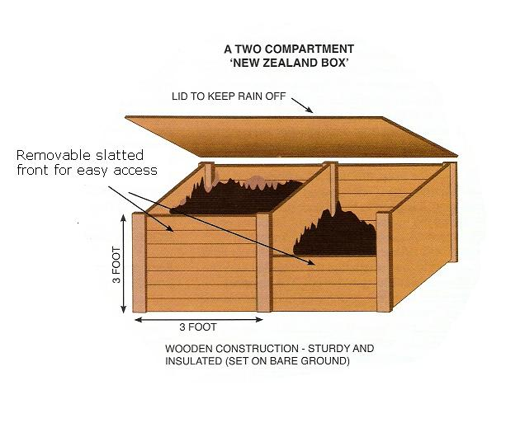
We recommend a 3-compartment ‘New Zealand Box’ type compost, as illustrated below – (only with 3 collection areas). Only one box will be left open at any one time. When one box is full, the compost is left to mature, and the next section is opened. The box will be protected from rodents by the use of chicken-wire mesh on the bottom, which will be secured up the sides.

Our proposal is to have 3 pilot areas for these compost schemes, perhaps in:
- Compass Quay
- Fort View, Summercove
- In the bowling green in front of Town Hall?

We’re open to suggestions as to where they should be located and how many to begin with. We estimate that the set-up costs for 3 compost sites would be in the region of €600, less if we can obtain recycled timber and wire.

3. Information Leaflets:

Purpose of leaflets:

- To promote a positive vision of how Kinsale could be in the future.
- To promote the importance of supporting local businesses, i.e., localisation.
- To raise awareness of the importance of growing food locally and supporting local growers (Farmer’s Market).
- To promote the Community Garden.
- To give tips on home Composting and promote the Community Composting Scheme.
- As a tourist information leaflet on the unique projects on the go in Kinsale.
- Energy Awareness: importance of energy conservation and energy efficiency. Energy saving tips for home and business.

It is quite difficult to estimate the costs of these leaflets as they have yet to be designed. Generally speaking design and printing of publicity material is usually in the region of €1,500-2,000.

Transition Times - newsletter

The Kinsale Newsletter has agreed to allocate a page in their newsletter every month to ‘Transition Times’ – the newsletter of Transition Design. This will be used to update the community on our various projects and related events in the town. We would like the permission of Kinsale Town Council to print the Town Council logo on this newsletter and say that the Transition Town concept is supported by Kinsale Town Council.

Other projects

Vital to our work here in Kinsale is the implementation of an Energy Audit in the town. This has been quoted at €40,000. Currently I am seeking funding elsewhere to cover this expense.

International interest

Already the international attention that has been generated from firstly the Energy Descent Action Plan and now the Transition Town concept has been enormous. On one global site, Energybulletin.net, the editor, Adam Fenderson said:

“Energy Bulletin averages over 300,000 unique 'visits' (1.5 million hits) a month according to our logs. We regularly carry stories on various solutions, but we are particularly focused on Kinsale because it has the growing potential to be one of the most positive Peak Oil stories in the world in the not too distant future. Having surveyed so many proposed solutions, their promises and shortcomings, I believe the approach being adopted in Kinsale offers one of the best examples of how the challenges we face, if confronted early and with a positive attitude, can be used to imagine and create more prosperous, sustainable and lively local communities.”

After the article ran in the Southern Star newspaper on January 14th it was picked up also by another website called: www.postcarbon.org, they reprinted the entire article.

The Energy Descent Plan has been purchased by people all over the world, and now that it is available for free download, it has been downloaded by hundreds more. As a result of this I have a visitor coming here from Willits in California in March to discuss what we are doing here. Also, another interested party from Australia wishes to visit next June, again to discuss what we are doing and how he could learn from it for his municipality.

As you can see, the attention is growing by the day. It’s up to us to manage the momentum and make the most of this unique opportunity.

Parting note

It is my wish to get the ball rolling on this project; however, this is not a one-woman show! After nominating a steering committee the ownership of the project will pass to the community. This is necessary for the empowerment of those in the community and for the project to be successful in the long term. At the moment all the work that has gone into this project has been entirely voluntary.

I would like to acknowledge Rob Hopkins, formerly of Kinsale Further Education College and now based in Totnes, U.K, for his vision and dedication which culminated in the Energy Descent Action Plan for Kinsale. We are deeply indebted to him for beginning this process here and awakening us to not only the challenges that lie ahead of us, but the creative solutions we could use to face those challenges. We are also sincerely grateful to Councillor Fred Treacy for having faith in us and for being possibly the first public representative to bring the issue of Peak Oil to the attention of local government anywhere in Ireland. We acknowledge our thanks also to Councillor Isabelle Sutton for her continued support of environmental concerns and for rallying behind our initiative without hesitation.

We gratefully acknowledge the support of the Town Council to date and are very much encouraged by the feedback we have received thus far.



